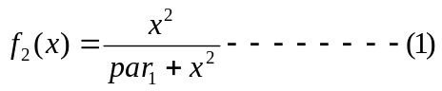
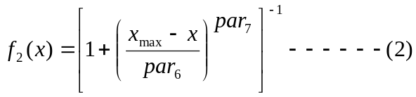
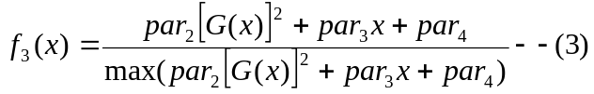

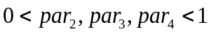

Where
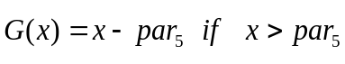
= 0 otherwise,

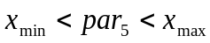

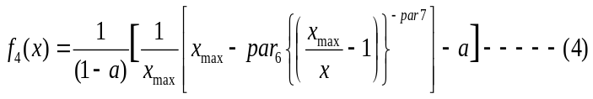
where
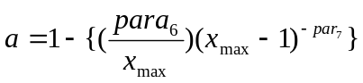

Here, gray_{min} and gray_{max} are the minimum and maximum value of the gray level range for an image.
Parameters Range
par₁-par₄  par₅ & par₆  par₇ | [0, 1]  (gray_{min} , gray_{max})  [1 , 3]

